POINT PLOT

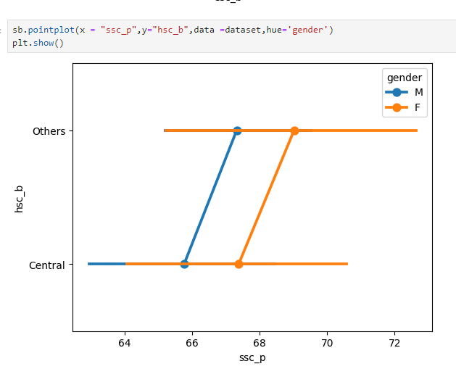

**What is a Point Plot?**

A point plot is a type of data visualization used to show the relationship between two categorical variables. It's particularly useful for comparing the means or medians of groups, along with their confidence intervals. Each point on the plot represents a summary statistic (usually the mean), and lines connect the points to show the trend or relationship across categories.

**Interpretation of the Attached Point Plot:**

1. **Axes**:
   * **x-axis (ssc_p)**: Represents the 10th-grade scores (SSC percentage).
   * **y-axis (hsc_b)**: Represents the type of higher secondary syllabus (Central or Others).
2. **Gender**:
   * The plot is colored by gender (hue='gender'), with blue representing males (M) and orange representing females (F).
3. **Key Observations**:
   * For the "Central" syllabus, both males and females have very close or identical SSC scores. The points for both genders overlap, indicating that their average or median SSC scores are nearly the same.
   * For the "Others" syllabus, the point plot shows a clearer separation between genders:
     + Males have lower SSC scores compared to females.
     + The line connecting the points suggests a difference in performance between genders, with females scoring higher than males in the "Others" syllabus.
4. **Trend**:
   * The lines connecting the points indicate that for the "Others" syllabus, there is a noticeable difference between male and female scores, with females generally scoring higher.
   * For the "Central" syllabus, the scores are more consistent and nearly the same for both genders.